**What protocol is used to map an IP address to a MAC address?**

a.DHCP

b.ICMP

c.HTTP

d.ARP

2.

**Which of the following is a valid MAC address format?**

a.AA:AA:12:34::AA:AA

b.AB:F1:1B:FE:12:D1:65:91

c.AB:12:12:CA:1F

d.AG:CA:1F:AA:11:DA

**What type of data transmission allows traffic to flow in both directions at the same time?**

a. Unidirectional

b. Simplex

c. Half-duplex

d. Full-duplex

**Which of the following describes a network that spans a city?**

1. CAN
2. LAN
3. MAN
4. WAN

**An IP address that can be used locally within your network and is not routable across the internet is known as what?**

1. An alternate private IP address
2. Private IP address
3. Public IP address
4. AR

**Which of these commands will display the MAC addresses of your interfaces? I**

1. Ipconfig /all
2. show mac
3. display mac
4. ifconfig /all

**What identifier does a switch use when making a forwarding decision?**

1. Destination IP address
2. Source IP address
3. Destination MAC address
4. Source MAC address

**A network that covers a small geographical area is known as a _______. Fill in the blank:**

a. LAN

b. MAN

c. WAN

**Which of the following is the broadcast MAC address?**

a. aa:aa:aa:aa:aa:aa

b. ff:ff:ff:ff:ff:ff

c. 11:11:11:11:11:11

d. 99:99:99:99:99:9

# Practical:

Install packet tracer and configure and setup a basic LAN, use the following as an example:



**Using packet tracer setup, the following scenario:**

**• a Server**

**• 2 switches**

**• 2 Student desktops**

**• 1 Employee Laptop**

**• 2 Employee Desktops**

**• The employee and Student network need to be separate but connect to the same server**

# Book homework

# Section 1

**1. Which of these refers to the connectivity between different external networks?**

(A) VPN  
(B) Intranet  
(C) Internet  
(D) DMZ

**2. Which of these does not allow us to identify a device on the network?**

(A) Virtual port number  
(B) IP address  
(C) MAC address  
(D) Hostname

**3. Replace the underlined word in the following statement with the correct word(s). If you believe the statement is already correct, then select *No change is required*:  
A DMZ allows or denies network traffic based on a set of rules.**

(A) VPN  
(B) Internet  
(C) Firewall  
(D) No change is required

**4. Which of these technologies allows you to securely connect to a private network over an insecure network?**

(A) Extranet  
(B) DMZ  
(C) Firewall  
(D) VPN

**5. Which of the following devices would you most likely position within a DMZ?**

(A) Domain controller  
(B) DHCP server  
(C) Print server  
(D) Web server

**6. What is the default security level for Restricted sites?**

(A) Low  
(B) Medium-Low  
(C) Medium-High  
(D) High

**7. What network protocol is used by the ping utility?**

(A) DHCP  
(B) ICMP  
(C) ARP  
(D) PPTP

**8. When would you use a VPN concentrator at both ends of the VPN tunnel?**

(A) When home-based users are connecting to the head office  
(B) When field-based engineers are connecting to the head office  
(C) When a branch office is connecting to the head office  
(D) None of the above

**9. Which of the following would you implement to allow trusted third parties to gain limited access to your internal network?**

(A) Extranet  
(B) DMZ  
(C) Firewall  
(D) Internet

# Section 2

**1. What protocol is used to map an IP address to a MAC address?**

(A) DHCP  
(B) ICMP  
(C)HTTP  
(D) ARP

**2. Which of the following is a valid MAC address format?**

(A) AA:AA:12:34::AA:AA  
(B) AB:F1:1B:FE:12:D1:65:91  
(C) AB:12:12:CA:1F  
(D) AG:CA:1F:AA:11:DA

**3. What type of data transmission allows traffic to flow in both directions at the same time?**

(A) Unidirectional  
(B) Simplex  
(C) Half-duplex  
(D) Full-duplex

**4. Which of the following describes a network that spans a city?**

(A) CAN  
(B) LAN  
(C) MAN  
(D) WAN

**5. An IP address that can be used locally within your network and is not routable across the internet is known as what?**

(A) An alternate private IP address  
(B) Private IP address  
(C) Public IP address  
(D) ARP

**6. Which of these commands will display the MAC addresses of your interfaces?**

(A) ipconfig /all  
(B) show mac  
(C) display mac  
(D) ifconfig /all

**7. What identifier does a switch use when making a forwarding decision?**

(A) Destination IP address  
(B) Source IP address  
(C) Destination MAC address  
(D) Source MAC address

**8. A network that covers a small geographical area is known as a _______. Fill in the blank:**

(A) CAN  
(B) LAN  
(C) MAN  
(D) WAN

**9. Which of the following is the broadcast MAC address?**

(A) aa:aa:aa:aa:aa:aa  
**(B) ff:ff:ff:ff:ff:ff**  
(C) 11:11:11:11:11:11  
(D) 99:99:99:99:99:99

**10. Looking at the following diagram, if Computer A sent a broadcast transmission, which devices would receive the data? Do not include Computer A in the count.**

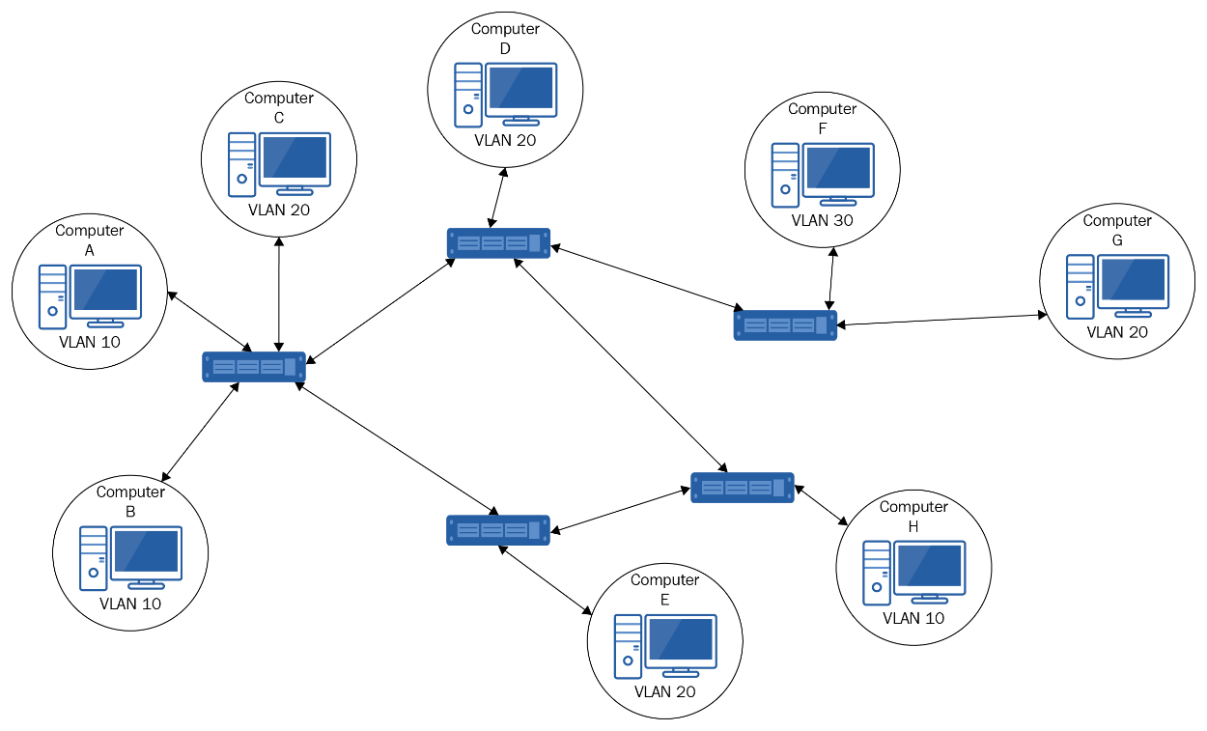

**(A) 2  
(B) 3  
(C) 7  
(D) 8**

# Section 3

**1. What type of network medium is used by SONET?**

(A) UTP  
(B) Coaxial  
(C) Wireless  
(D) Optical

**2. What is the speed of an E3 connection?**

(A) 1.544 Mb/s  
(B) 2.048 Mb/s  
(C) 34.368 Mb/s  
(D) 44.736 Mb/s

**3. Which devices convert digital signals to analog signals for transmission over the telephone network?**

(A) Modem  
(B) Switch  
(C) Router  
(D) Telnet

**4. Which device in a packet-switching network is most likely to function as a PAD?**

(A) Modem  
(B) Switch  
(C) Router  
(D) Telnet

**5. How many B channels does an ISDN Basic Rate Interface have?**

(A) 1  
(B) 2  
(C) 3  
(D) 4

**6. Which WAN technology used fixed-size cells to transfer data?**

(A) Frame relay  
(B) Packet switching  
(C) ATM  
(D) 3G

**7. Which of the following is used for error checking in X.25 networks?**

(A) CRC  
(B) ATM  
(C) ECC  
(D) PSE

**8. If you had a committed information rate (CIR) of 128 Kb/s, what would the burst excess be?**

(A) 128 Kb/s  
(B) 192 Kb/s  
(C) 224 Kb/s  
(D) 320 Kb/s

**9. What device routes traffic around a packet-switched network?**

(A) PSE  
(B) PAD  
(C) CSU/DSU  
(D) DTE

# Section 4

**Wi-Fi networks use which access method?**

(A) Token ring  
(B) CSMA/CD  
(C) CSMA/CW  
(D) CSMA/CA

**2. A junior network technician needs to set up an access point using 802.11g. What frequency will it use?**

(A) 2.4 Hz  
(B) 2.4 KHz  
(C) 2.4 GHz  
(D) 2.5 THz

**3. Which 802.11 standard has the furthest indoor range?**

(A) 802.11g  
(B) 802.11a  
(C) 802.11n  
(D) 802.11ac

**4. What type of wireless topology would be used when you want to connect two devices directly together in a peer-to-peer relationship?**

(A) WDS  
(B) Ad-hoc mode  
(C) Infrastructure mode  
(D) Wireless bridge

**5. Which of these Wi-Fi security standards takes advantage of EAP?**

(A) WEP-PSK  
(B) WEP-Enterprise  
(C) WPA-PSK  
(D) WPA2-Enterprise

**6. Which of these Wi-Fi standards does not use a 5 GHz frequency?**

(A) 802.11b  
(B) 802.11a  
(C) 802.11n  
(D) 802.11ac

**7. You have a wireless network that supports 802.11g, but you have noticed that the network seems to be running at 11 Mbps. What is the most likely cause of this?**

(A) EMI  
(B) Incorrect encryption standard selected  
(C) Interference from Bluetooth devices  
(D) You have an 802.11b device on the network

**8. The EAP falls under which standard?**

(A) 802.1a  
(B) 802.1x  
(C) 802.11b  
(D) 802.11x

# Section 5

**1. In a token ring network, what is the central device known as?**

(A) MAU  
(B) Switch  
(C) Router  
(D) Server

**2. Which access method is used on a bus topology?**

(A) Token  
(B) CSMA/CA  
(C) Ticket  
(D) CSMA/CD

**3. All devices in a star topology are unable to communicate with each other. What is most likely at fault?**

(A) Operating system  
(B) Network card  
(C) Switch  
(D) Cable

**4. FDDI utilizes which form of topology?**

(A) Bus  
(B) Ring  
(C) Star  
(D) Mesh

**5. In a full mesh network consisting of five devices, how many interfaces are required in total?**

(A) 4  
(B) 5  
(C) 10  
(D) 20

**6. Which topology offers the best fault tolerance?**

(A) Full mesh  
(B) Star  
(C) Partial mesh  
(D) Bus

**7. Which IEEE standard covers token ring?**

(A) 802.1  
(B) 802.3  
(C) 802.5  
(D) 802.15

**8. Which type of topology is shown in the following diagram?**

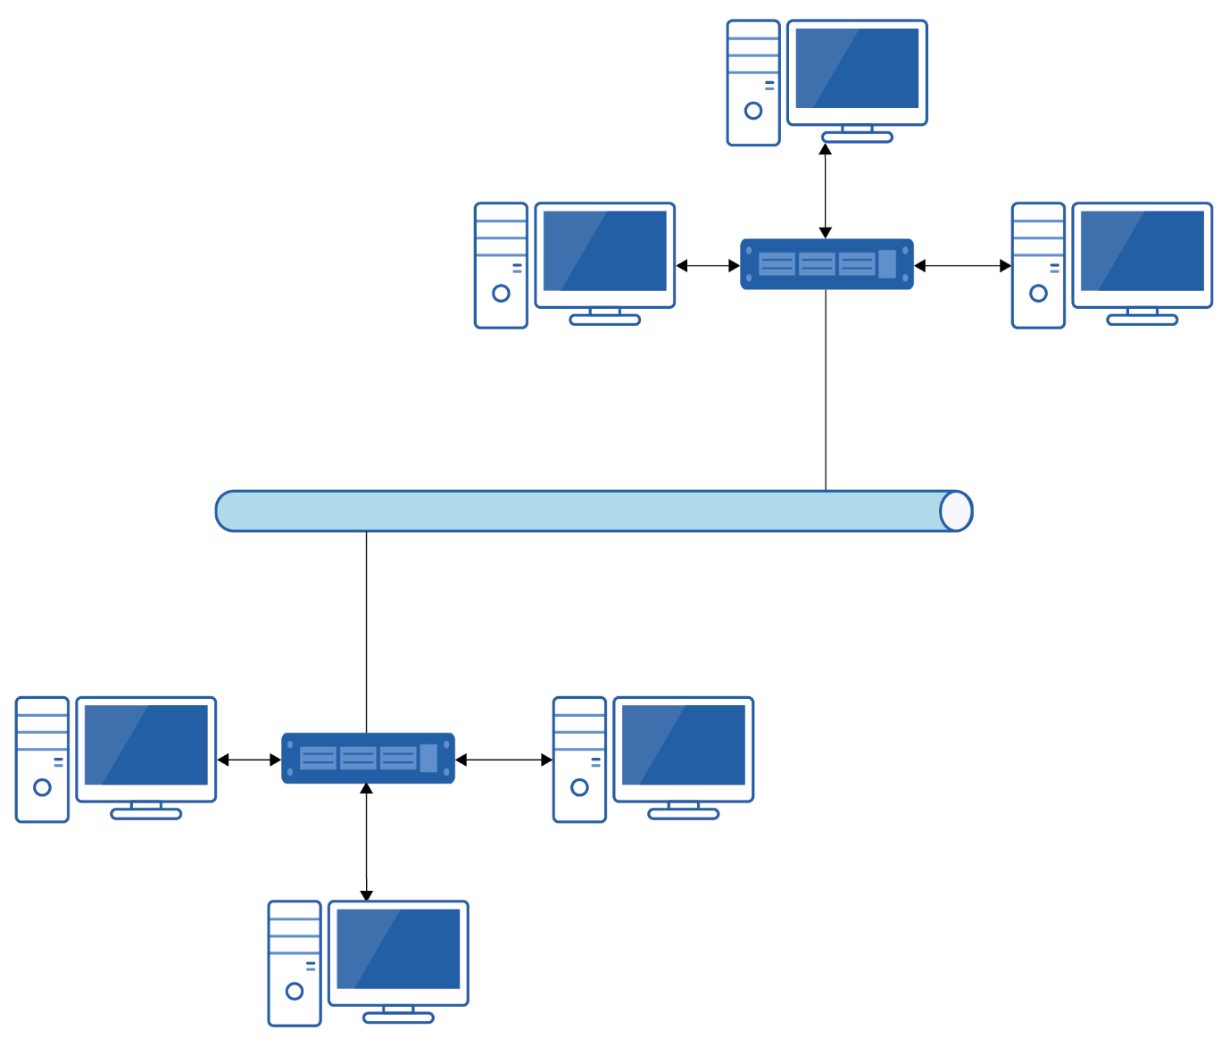

(A) Bus  
(B) Partial mesh  
(C) Star  
(D) Hybrid